INDEX
S.N | Praticle | Date | Signature
1 | Write the program to implement breadth first search and Depth first search. | 2083-03-26
2 | Write a program to implement A* search. | 2083-03-29
3 | Write a program to implement greedy best search. | 2083-03-29
4 | Write a prolong program to represent few basic facts and perform queries (example elephant is an animal. Elephant is bigger than horse etc). | 2083-03-30
5 | Form the figure tree:  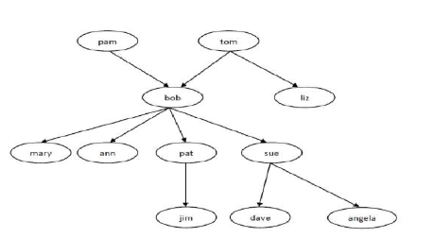  1. Represent all members of family with their gender as property.  2. Represent all parent relationship of the family (i.e all the facts of form parent (X,Y)).  3. Is tom parents of jim?  4. Is angela male?  5. Is bob parents of pat?  6. Is liz parents of pat? | 2083-03-32
6 | From above family tree list following:  - List all male family members.  - List all female family members.  - Who is liz’s parent?  - Who are bob’s children?  - Find all parent children relationship. (find all X and Y such that X is parents of Y)  - Who is grand parents of jim?  - List all the sister of pat  - List all the uncle of angela. | 2083-03-32
7 | Repents following facts using prolog:  If a student study they will pass the exam.  If the students pass their exam, they will be happy.  Anisha studied for the exam.  Sachin studied for the exam.  Bibek studied for exam.  Anuj did not study for the exam.  Nisha did not study for the exam.  Using the facts, answer following  - Did anuj Pass?  - List all the students that passed  - Did bibek study?  - List all the students that did not study. | 2083-04-01
8 | Write a program using c or java implement AND, OR, NOT and XOR gate. | 2083-04-01

- Write the program to implement breadth first search and Depth first search.
package Unit1;

import java.util.*;

public class Graph {
// Changed Map from Integer to String
private Map<String, List<String>> adj = new HashMap<>();

public void addEdge(String v, String w) {
adj.computeIfAbsent(v, k -> new ArrayList<>()).add(w);
}

public void BFS(String start) {
Queue<String> queue = new LinkedList<>();
Set<String> visited = new HashSet<>();
queue.add(start);
visited.add(start);

System.out.print("BFS Traversal: ");
while (!queue.isEmpty()) {
String n = queue.poll();
System.out.print(n + " ");
for (String neighbor : adj.getOrDefault(n, new ArrayList<>())) {
if (!visited.contains(neighbor)) {
visited.add(neighbor);
queue.add(neighbor);
}
}
}
System.out.println();
}

public void DFS(String v, Set<String> visited) {
visited.add(v);
System.out.print(v + " ");
for (String neighbor : adj.getOrDefault(v, new ArrayList<>())) {
if (!visited.contains(neighbor)) DFS(neighbor, visited);
}
}

public static void main(String[] args) {
Graph g = new Graph();

// Building the SAGAR path: S -> A -> G -> A -> R
g.addEdge("S", "A");
g.addEdge("A", "G");
g.addEdge("G", "A");
g.addEdge("A", "R");

// Run BFS
g.BFS("S");

// Run DFS
System.out.print("DFS Traversal: ");
g.DFS("S", new HashSet<>());
}
}

OUTPUT
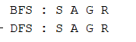
- Write a program to implement A* search.
A* Search Logic Overview
- Initialize: Place the start node into the OPEN list.
- Evaluate: Select the node $n$ from OPEN with the smallest evaluation function $f(n) = g(n) + h(n)$.
- Goal Check: If $n$ is the goal, return the path.
- Expand: Generate all successors of $n$, calculate their $f(n)$ values, and add them to the OPEN list.
- Track: Keep generated nodes in CLOSED to ensure we don't re-process them, effectively finding the optimal path efficiently.
package Unit1;

import java.util.*;

public class AStarSearch {
// Stores graph: Node -> Map of (Neighbor -> Cost)
static Map<String, Map<String, Integer>> adj = new HashMap<>();
static Map<String, Integer> h = new HashMap<>();

public static void main(String[] args) {
// Setup graph
addEdge("S", "A", 1); addEdge("S", "G", 10);
addEdge("A", "C", 1); addEdge("A", "B", 2);
addEdge("C", "G", 4);

// Setup heuristics
h.put("S", 5); h.put("A", 3); h.put("B", 4); h.put("C", 2); h.put("G", 0);

aStar("S", "G");
}

static void aStar(String start, String goal) {
PriorityQueue<Node> open = new PriorityQueue<>(Comparator.comparingInt(n -> n.f));
open.add(new Node(start, 0, h.get(start), null));

while (!open.isEmpty()) {
Node curr = open.poll();
if (curr.name.equals(goal)) { printPath(curr); return; }

for (var neighbor : adj.getOrDefault(curr.name, new HashMap<>()).entrySet()) {
open.add(new Node(neighbor.getKey(), curr.g + neighbor.getValue(), h.get(neighbor.getKey()), curr));
}
}
}

static void addEdge(String u, String v, int w) {
adj.computeIfAbsent(u, k -> new HashMap<>()).put(v, w);
}

static void printPath(Node n) {
List<String> path = new ArrayList<>();
while (n != null) { path.add(n.name); n = n.parent; }
Collections.reverse(path);
System.out.println("Optimal Path: " + String.join(" -> ", path));
}

static class Node {
String name; int g, f; Node parent;
Node(String n, int g, int h, Node p) { this.name = n; this.g = g; this.f = g + h; this.parent = p; }
}
}

OUTPUT

- Write a program to implement greedy best search.
package Unit1;

import java.util.*;

public class GreedySearch {
static Map<String, Map<String, Integer>> adj = new HashMap<>();
static Map<String, Integer> h = new HashMap<>();

public static void main(String[] args) {
addEdge("S", "A", 1); addEdge("S", "B", 4);
addEdge("A", "C", 2); addEdge("B", "G", 1);
addEdge("C", "G", 3);

h.put("S", 5); h.put("A", 3); h.put("B", 2); h.put("C", 1); h.put("G", 0);

greedySearch("S", "G");
}

static void greedySearch(String start, String goal) {
// PriorityQueue orders nodes by their heuristic value h(n)
PriorityQueue<Node> open = new PriorityQueue<>(Comparator.comparingInt(n -> n.h));
open.add(new Node(start, h.get(start), null));

System.out.print("GreedySearchPath: ");
while (!open.isEmpty()) {
Node curr = open.poll();
System.out.print(curr.name + " ");
if (curr.name.equals(goal)) return;

for (var neighbor : adj.getOrDefault(curr.name, new HashMap<>()).entrySet()) {
open.add(new Node(neighbor.getKey(), h.get(neighbor.getKey()), curr));
}
}
}

static void addEdge(String u, String v, int w) {
adj.computeIfAbsent(u, k -> new HashMap<>()).put(v, w);
}

static class Node {
String name; int h; Node parent;
Node(String n, int h, Node p) { this.name = n; this.h = h; this.parent = p; }
}
}
OUTPUT

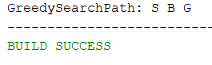
- Write a prolong program to represent few basic facts and perform queries (example elephant is an animal. Elephant is bigger than horse etc).
SOLUTION

% Facts: basic information about entities
animal(rhino).
animal(donkey).
animal(cat).
animal(dog).
bird(crow).
bird(pigeon).
bird(parrot).

% Facts: direct relationships
bigger_than(rhino, donkey).
bigger_than(donkey, dog).
bigger_than(dog, cat).
bigger_than(cat, crow).

% Rule: Recursive logic to determine indirect relationships
% X is bigger than Y if X is bigger than Z, AND Z is bigger than Y
bigger_than(X, Y) :-
bigger_than(X, Z),
bigger_than(Z, Y).

% Rule: Inverse relationship
smaller_than(X, Y) :-
bigger_than(Y, X).

animal(rhino)
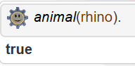

bird(parrot).
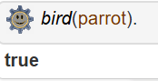

bigger_than(cat, crow)
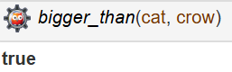

smaller_than(dog, donkey).
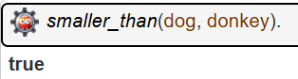

bigger_than(rhino, crow).
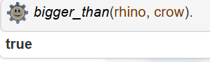
Query Step | Goal | Status
Step 1 | bigger_than(rhino, donkey) | Fact (True)
Step 2 | bigger_than(donkey, dog) | Fact (True)
Step 3 | bigger_than(dog, cat) | Fact (True)
Step 4 | bigger_than(cat, crow) | Fact (True)
Final Result | bigger_than(rhino, crow) | True (Inferred)



For the above family tree:
1. Represent all members of family with their gender as property.
2. Represent all parent relationship of the family (i.e all the facts of form parent (X,Y)).
3. Is tom parents of jim?
4. Is angela male?
5. Is bob parents of pat?
6. Is liz parents of pat?
CODE:
1 answer : % Gender
female(pam). female(ann). female(liz). female(angela). female(sue). female(mary).
male(pat). male(bob). male(tom). male(jim). male(dave).

2 Answer % Parents
parent(bob, mary). parent(bob, ann). parent(bob, pat). parent(bob, sue).
parent(tom, liz). parent(tom, bob). parent(pam, bob).
parent(sue, dave). parent(sue, angela). parent(pat, jim).

% Rules
mother(X, Y) :- parent(X, Y), female(X).
father(X, Y) :- parent(X, Y), male(X).
grandparent(X, Y) :- parent(Z, Y), parent(X, Z).
sister(X, Y) :- parent(Z, X), parent(Z, Y), female(X), X \= Y.
uncle(X, Z) :- brother(X, Y), parent(Y, Z).

3 Answer
parent(tom, jim).
Output
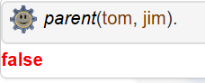

4 Answer
male(angela).
Output
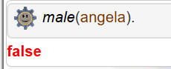

5 Answer
grandparent(X, jim).

OUTPUT

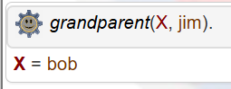

6 Answer
sister(X, pat).
OUTPUT
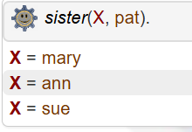
- From above family tree list following:
- List all male family members.
- List all female family members.
- Who is liz’s parent?
- Who are bob’s children?
- Find all parent children relationship. (find all X and Y such that X is parents of Y)
- Who is grand parents of jim?
- List all the sister of pat
- List all the uncle of angela.

CODE:
% Facts: Gender
female(pam). female(ann). female(liz). female(angela). female(sue). female(mary).
male(pat). male(bob). male(tom). male(jim). male(dave).

% Facts: Parent relationships
parent(bob, mary). parent(bob, ann). parent(bob, pat). parent(bob, sue).
parent(tom, liz). parent(tom, bob).
parent(pam, bob).
parent(sue, dave). parent(sue, angela).
parent(pat, jim).

% Rules
father(X, Y) :- parent(X, Y), male(X).
brother(X, Y) :- parent(Z, X), parent(Z, Y), male(X), X \= Y.
sister(X, Y) :- parent(Z, X), parent(Z, Y), female(X), X \= Y.
grandparent(X, Y) :- parent(Z, Y), parent(X, Z).
uncle(X, Z) :- brother(X, Y), parent(Y, Z).
children(X, Y) :- parent(Y, X).

I Answer
male(X).
OUTPUT:
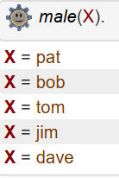

II ANSWER:
female(X).
OUTPUT:
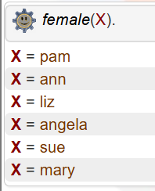

III ANSWER:
parent(X, liz).
OUTPUT:
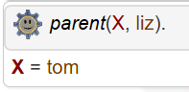

IV ANSWER:
children(X, bob).
OUTPUT:
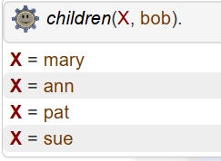

V ANSWER:
parent(X, Y).
OUTPUT:
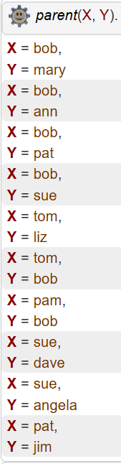

VI ANSWER:
grandparent(X, jim).
OUTPUT:
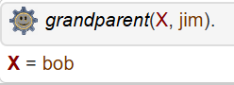
Since Pat is parent of Jim and Bob is parent of Pat

VII ANSWER:
sister(X, pat).
OUTPUT
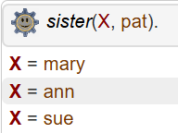

VIII ANSWER
uncle(X, angela).
OUTPUT:
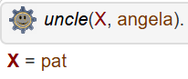
Pat is the brother of Sue, who is the mother of Angela
- Repents following facts using prolog:
If a student study they will pass the exam.
If the students pass their exam, they will be happy.
Anisha studied for the exam.
Sachin studied for the exam.
Bibek studied for exam.
Anuj did not study for the exam.
Nisha did not study for the exam.
Using the facts, answer following
- Did anuj Pass?
- List all the students that passed
- Did bibek study?
- List all the students that did not sudy.

SOUTION
% Rules
pass(X) :- study(X).
happy(X) :- pass(X).

% Facts
study(anisha). study(sachin). study(bibek).
% Anuj and Nisha did not study, so we do not declare them as facts of study(X).

I answer
pass(anuj).
OUTPUT:
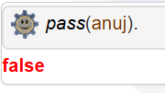

II Answer:
pass(X).
OUTPUT:
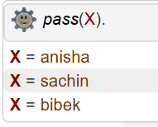

III ANSWER
study(bibek).

OUTPUT
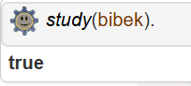

IV Answer
student(X), \+ study(X).

OUTPUT
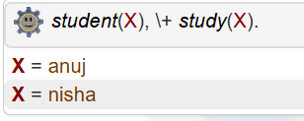

- Write a program using c or java implement AND, OR, NOT and XOR gate.

package Unit1;

public class LogicGatesTable {
public static void main(String[] args) {
boolean A = true;
boolean B = false;

System.out.println("--- Logic Gate Truth Table ---");
System.out.println("A AND B: " + (A && B)); // AND: True only if both are true
System.out.println("A OR B : " + (A || B)); // OR: True if at least one is true
System.out.println("NOT A : " + (!A)); // NOT: Inverts the value
System.out.println("A XOR B: " + (A ^ B)); // XOR: True if inputs are different
}
}

OUTPUT

